6. Create a collection in Postman and create positive and negative cases for below API. And use post method to get valid responses.
Verify the HTTP Status Codes, while running Positive and Negative Test Cases.
To validate the HTTP Status Codes and responses use Assertions concept in PostMan. Please implement the same using Groovy Script in Postman
https://reqres.in/api/login

API:
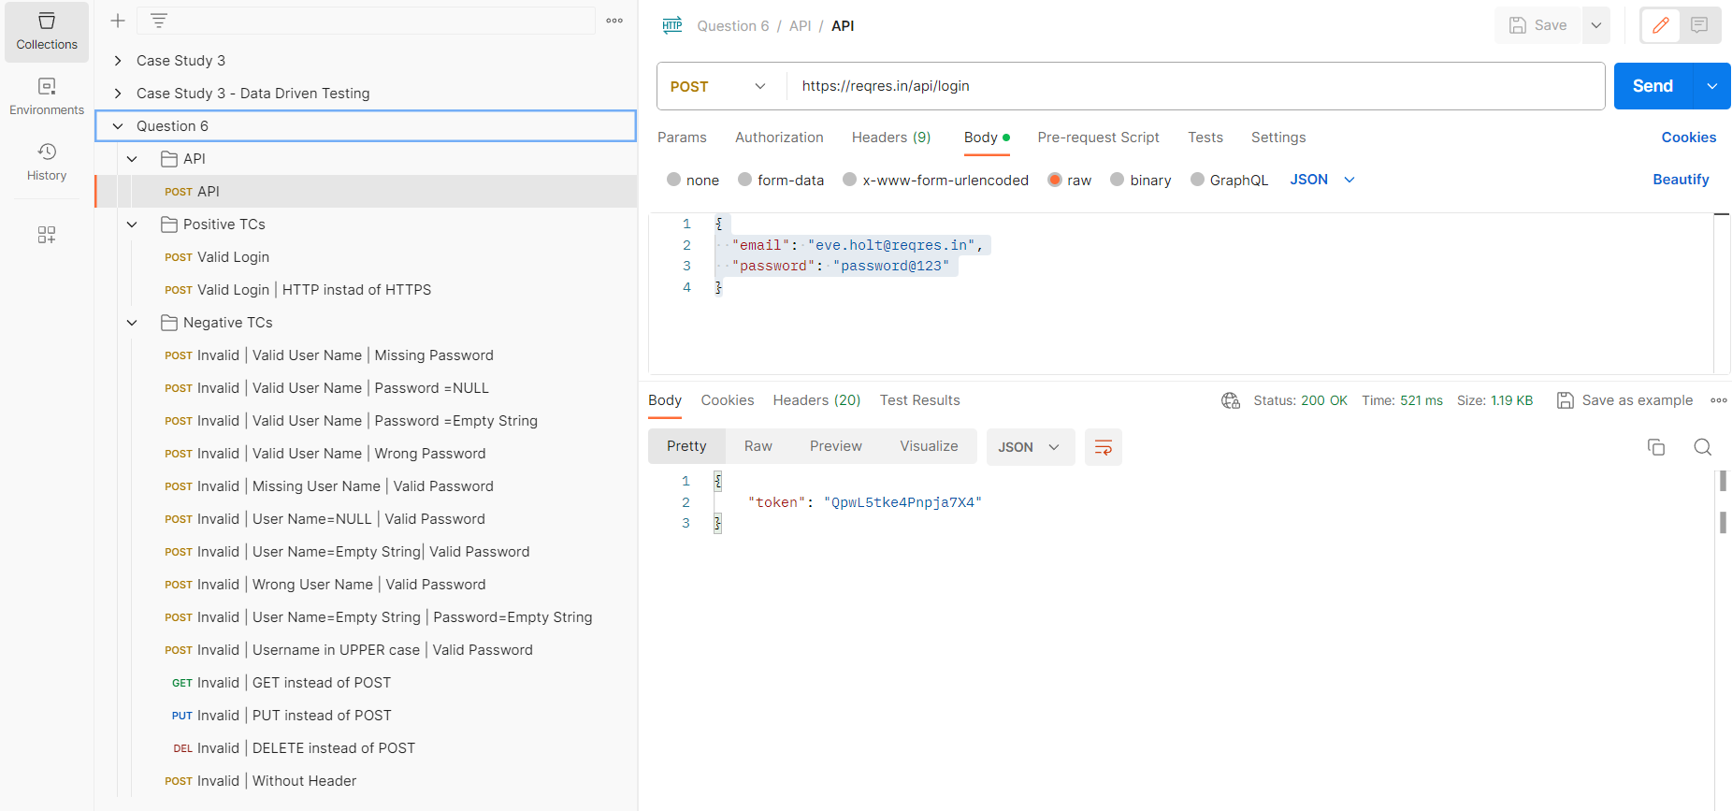

Positive Testcases:

/////////////////// Verify response code and header ///////////////////

pm.test("Verifying Response Status code : 200", function () {
pm.response.to.have.status(200);
});

pm.test("Verifying Response Status code name : OK", () => {
pm.response.to.have.status("OK");
});

pm.test("Verifying Content-Type header : application/json", () => {
pm.expect(pm.response.headers.get('Content-Type')).to.eql('application/json; charset=utf-8');
});

pm.test("Verifying Response time is less than 2s", () => {
pm.expect(pm.response.responseTime).to.be.below(5000);
});

/////////////////// Verify response body ///////////////////

const responseJson = pm.response.json();

pm.test("Verifying that response is a JSON object", () => {
pm.expect(responseJson).to.be.an("object");
});

pm.test("Verifying that 'token' is a string", () => {
pm.expect(responseJson.token).to.be.a("string");
});

pm.test("Verifying that token value is correct", function () {
pm.expect(responseJson.token).to.eql("QpwL5tke4Pnpja7X4");
});
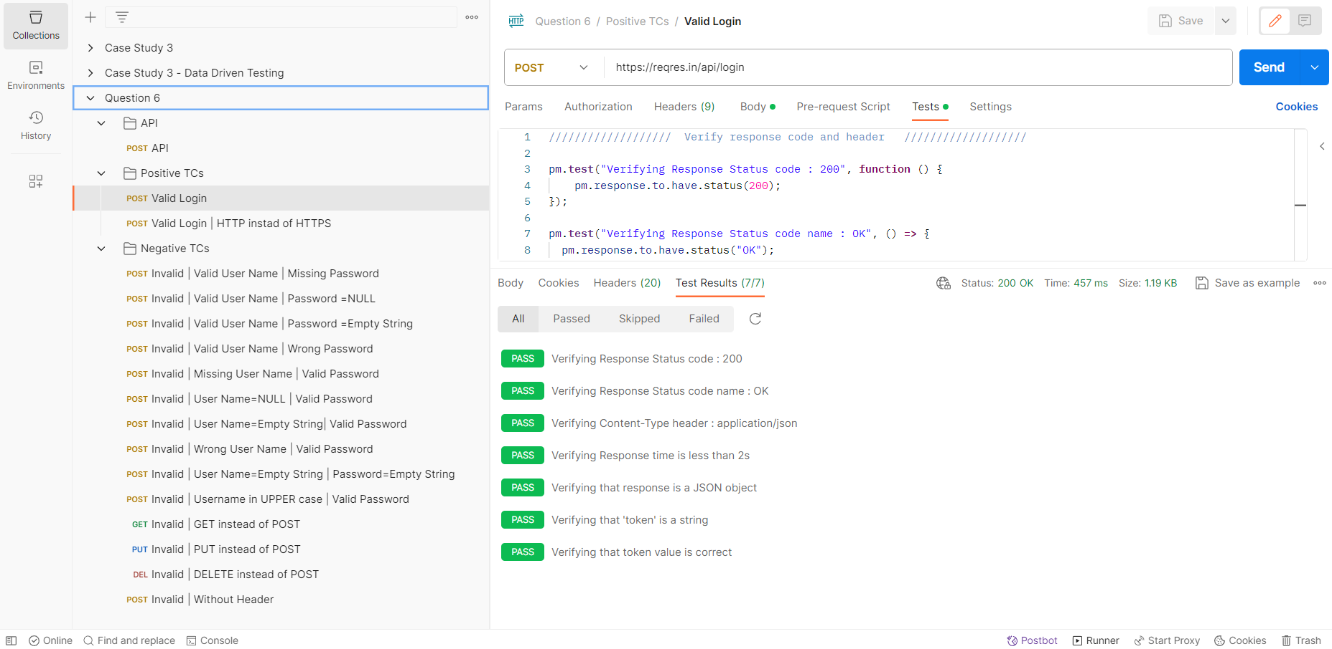

Negative Testcases:
/////////////////// Verify response code and header ///////////////////

pm.test("Verifying Response Status code : 400", function () {
pm.response.to.have.status(400);
});

pm.test("Verifying Response Status code name : Bad Request", () => {
pm.response.to.have.status("Bad Request");
});

pm.test("Verifying Content-Type header : application/json", () => {
pm.expect(pm.response.headers.get('Content-Type')).to.eql('application/json; charset=utf-8');
});

pm.test("Verifying Response time is less than 2s", () => {
pm.expect(pm.response.responseTime).to.be.below(5000);
});

/////////////////// Verify response body ///////////////////

const responseJson = pm.response.json();

pm.test("Verifying that response is a JSON object", () => {
pm.expect(responseJson).to.be.an("object");
});

pm.test("Verifying that error message is a string", () => {
pm.expect(responseJson.error).to.be.a("string");
});

pm.test("Verifying that error message is correct", function () {
pm.expect(responseJson.error).to.eql("Missing email or username");
});

